Title

Troubleshooting Internet Explorer

Prepared By
Helpdesk

Date: Monday, July 19, 2010

Version 2.0

Document History

Date | Author | Revision | Description
26-10-2010 | Team Lead Helpdesk | 1.0 | Document Creation
08-10-2018 | Team Lead Helpdesk | 2.0 | Company Name changed from TBSS to CBSL

Approved By: | Conneqt Business Solutions Limited
Manager-Technology | 2.0

Distribution List
Name | Department | Company | Rights
Manager-IT Support | Technology | CBSL | Review & Comment
Manager-Technology | Technology | CBSL | Modify
AVP Technology | Technology | CBSL | Review & Approve

Security Classification: Tata BSS Restricted.

1.The reason for this problem is that the Lan Connectivy disable then
If it showing cross mark then check the port and cable to get the IP
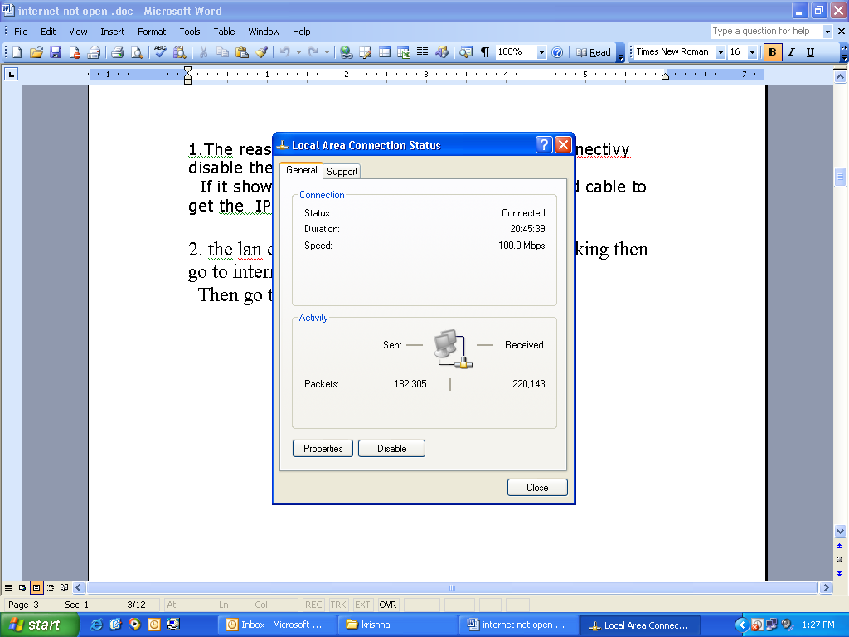

2. the lan connection is fine and internet not working then go to internet explorer Browser
Then go to tools →.internet options →
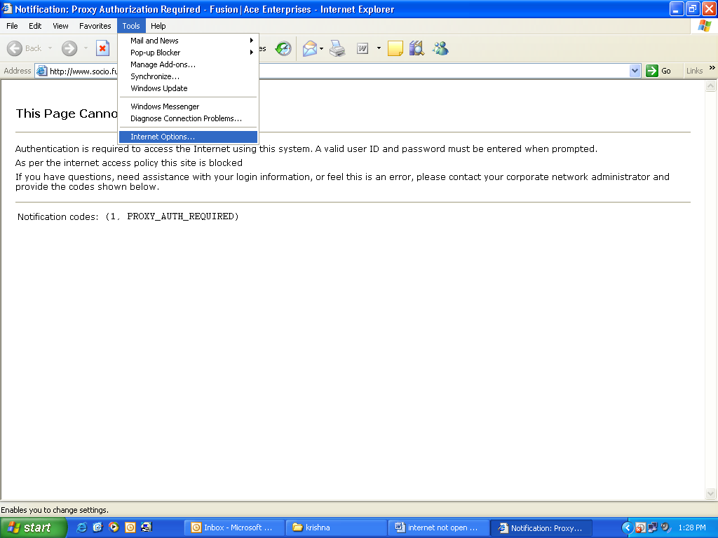

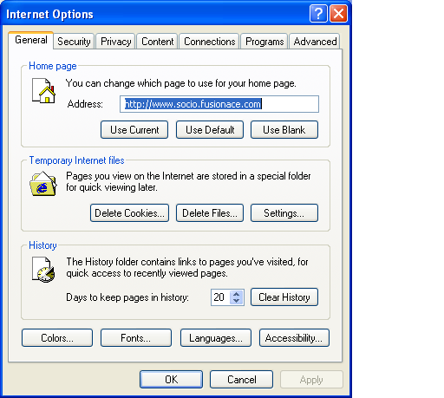

In internet options\internet tab\custom level
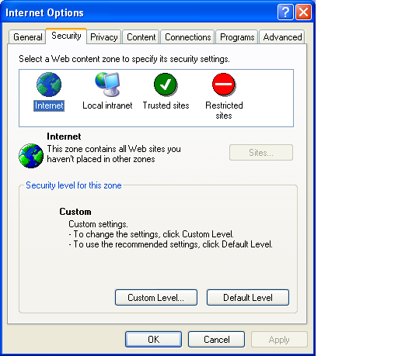

Check all options should be enabled
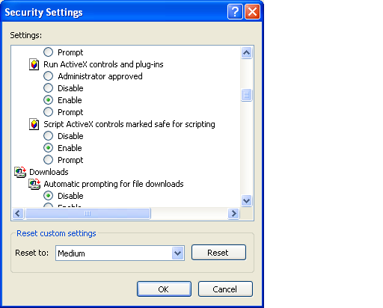

Expect pop-up blocker should be disabled mode

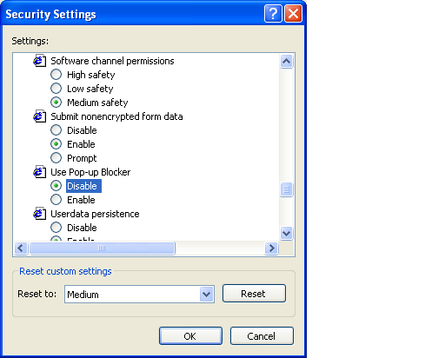

As same as check local intranet tab
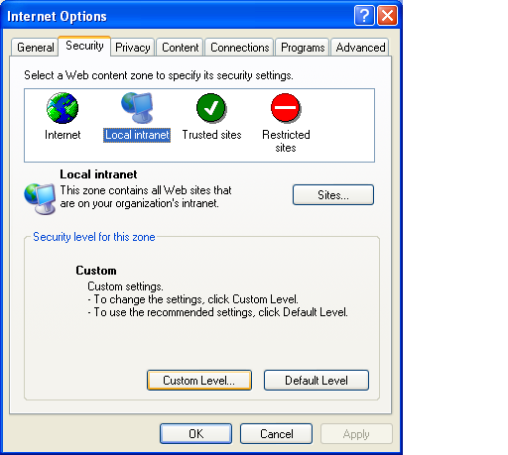

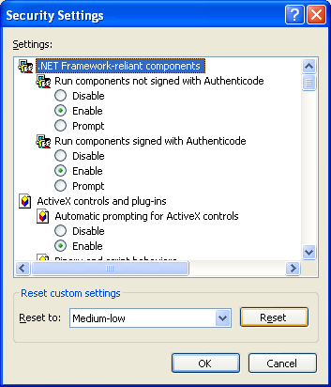

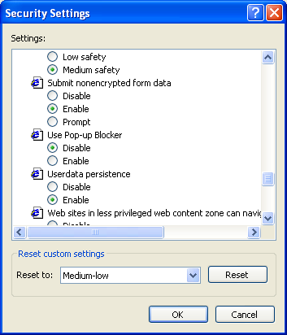

Check it privacy tab
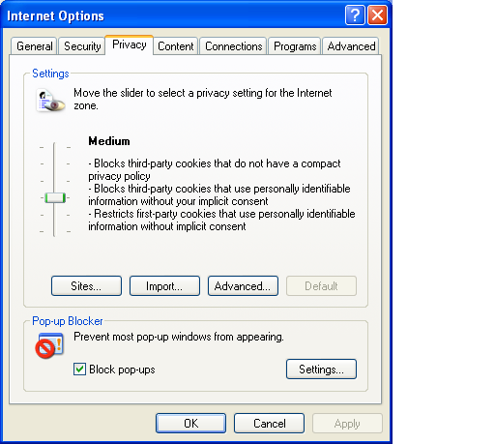

Go to connection → lan settings → check the proxy server settings

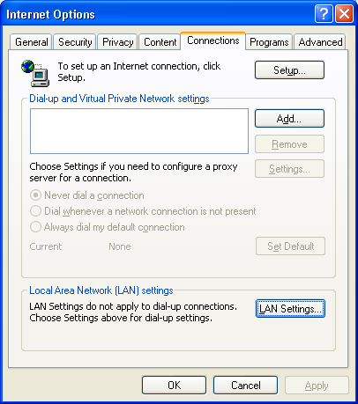

Chek the The Proxy Settings as Shown Below
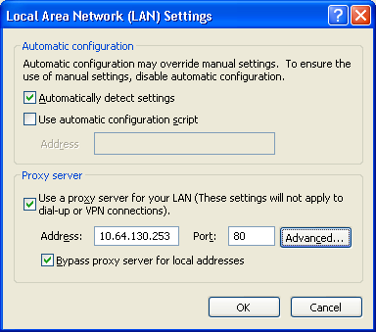

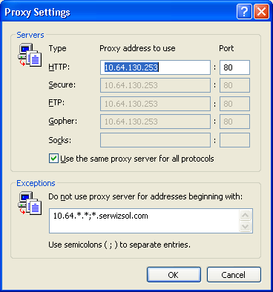
Then Checked It Working Fine.

